**Performance Test Report**

**For**

**Execution of**

**Masterdata getApplicanttype – 250 users**

Date: 05 June 2020

Author: Gaurav Sharan

**Summary**

This report presents the observations and findings of the load test conducted for a load of 250 users on masterdata getApplicanttype API.

The objective of this load test was to observe and record behavior of the application when user load is increased from 75 to 250.

Below are the scenario details:

|  |  |
| --- | --- |
| **Script/Report Name** | Masterdata gtApplicanttype API |
| **Run Date** | 05-June-2020 |
| **Period** | 13:10:04 UTC to 14:08:58 UTC |
| **Number of concurrent users** | 75 to 250 |
| **Ramp up** | 01 user per second |
| **Run Duration** | --- |
| **Ramp down** | NA |

The transaction response times observed were as below:

|  |  |  |  |  |  |  |  |
| --- | --- | --- | --- | --- | --- | --- | --- |
| **Label** | **# Samples** | **Average(ms)** | **90% Line(ms)** | **Min(ms)** | **Max(ms)** | **Error %** | **Throughput** |
| TR_masterdata_ getApplicanttype | 166482 | 2273 | 5388 | 8 | 60285 | 11.87% | 47.1 |

**Performance Test Execution Details**

We have executed JMeter script for masterdata getapplicanttype service, which has transactions mentioned in the above table.

Average response time of the APIs is 2273 ms with error rate ~12 %.

**Response Time and TPS Graph:**

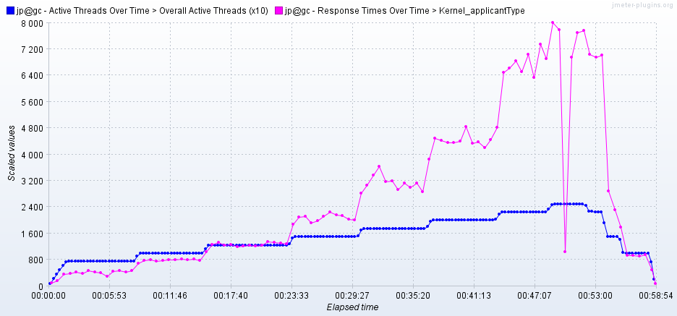

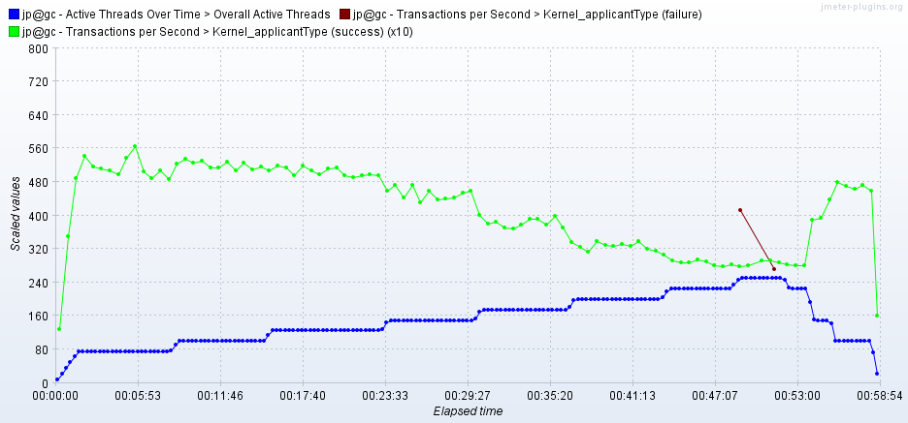

As seen in the graph, response time of the APIs is approx 2.2 second when 150 users are active, and response time increases with increase in number of users.

Response time crosses 7 sec when 250 users are active.

Failures are observed when 250 users are active.

Throughput (TPS) of the APIs approxes 49 when 125 users are active and reduces with increase in number of users.